The Definitive Architecture of Cinematic Video Generation: A Comprehensive Analysis of xAI’s Grok Imagine Capabilities and Prompt Engineering
The landscape of generative artificial intelligence has undergone a profound paradigm shift with the introduction of advanced autoregressive mixture-of-experts architectures in video generation. Specifically, the evolution of xAI’s Grok video generation model, code-named Aurora, integrated within the Grok AI chatbot and accessible via the Grok Imagine API, has established new empirical benchmarks for instruction adherence, motion consistency, and native audiovisual synthesis.¹ As AI transitions from a novelty tool into a professional production utility, producing high-fidelity, Hollywood-grade cinematic outputs requires a rigorous understanding of the model's token-weighting mechanics, semantic processing logic, and strict technical constraints. The era of casual prompting has concluded; the current frontier demands the exactitude of a director of photography merged with the algorithmic intuition of a data scientist.
This comprehensive research report systematically deconstructs the operational parameters of Grok’s video generation engine, providing an exhaustive manual for AI cinematography. By synthesizing empirical generation data, industry-standard cinematography frameworks, and advanced prompt engineering protocols, this document establishes a foundational blueprint for directing AI-generated cinema. The ensuing analysis spans foundational technical capabilities, multi-layered prompting taxonomies, specialized genre execution, and structured templates explicitly designed to maximize the efficacy of text-to-video and image-to-video workflows. Every element utilized in the professional film industry—from focal lengths and lens characteristics to subsurface scattering algorithms and Foley acoustic envelopes—is meticulously analyzed to empower creators to produce unprecedented cinematic quality using the Grok ecosystem.

1. Technical Framework and Operational Capabilities
The Grok Imagine video model represents a significant evolution in generative media, moving decisively beyond rudimentary diffusion models to an autoregressive architecture trained on vast multimodal datasets.³ This sophisticated architecture predicts image and audio tokens sequentially rather than relying purely on global denoising, which affords unprecedented control over temporal consistency across frames.³ Crucially, this system allows for the native generation of synchronized soundscapes, dialogue, and foley without requiring secondary post-production audio layers, fundamentally altering the traditional post-production pipeline.³

1.1 Generation Modes and Modalities
The Grok ecosystem supports several distinct modalities for video synthesis, accommodating both rapid conceptual ideation and precise editorial control. Each modality processes data differently and requires a tailored approach to input management.
The primary modality is Text-to-Video generation, which synthesizes novel video sequences directly from natural language prompts.⁴ This mode demands extraordinary specificity in environmental, mechanical, and aesthetic descriptions, as the prompt carries the entire burden of defining the latent space generation.³ Without visual anchors, the model relies entirely on the linguistic precision of the user to define spatial geometry and temporal flow.
Conversely, Image-to-Video animation utilizes a static source image—provided either via a public URL or a base64-encoded data URI—imposing motion, environmental dynamics, and atmospheric changes while preserving the structural integrity and aesthetic foundation of the initial frame.⁵ This modality is heavily favored by professional creators who utilize external image generation models (such as Midjourney or specialized local diffusion models) to lock in an exact composition and character design before initiating motion.⁶
For projects requiring continuity without rigid initial framing, the Reference-to-Video mode allows users to upload up to seven distinct reference images.⁵ The model analyzes these references to extract specific character likenesses, object geometries, or stylistic color palettes, subsequently weaving these elements into a novel generation sequence without locking the composition of the first frame.⁵ This is particularly useful for commercial advertising where product consistency is paramount.
To facilitate post-production refinement, the Edit-Video capability allows for targeted modifications within an existing video sequence.⁴ Utilizing text instructions, creators can alter weather conditions, modify subject attire, or restyle an entire sequence while the system maintains strict scene preservation and temporal tracking of the original underlying structure.²
Finally, the Extend-Video feature addresses the inherent duration limitations of generative models. By feeding the final frame of an existing sequence back into the model along with continuation prompts, creators can generate sequential continuations.⁵ This chaining technique enables the construction of long-form, cohesive narratives, allowing editors to stitch 6-second segments into continuous 30-second or multi-minute sequences.⁷

1.2 Output Parameters and Technical Constraints
Precision in AI filmmaking requires operating strictly within the model's technical boundaries. The Grok Imagine API and user interface impose specific parameter constraints that dictate prompt execution and overall workflow strategy.
Duration limits are strictly enforced across the ecosystem. Standard generations span a range of 1 to 15 seconds.⁵ However, specialized operations are bound by tighter constraints; Reference-to-Video modes are strictly capped at 10 seconds, while video editing operations output a maximum of 8.7 seconds to precisely match input constraints.⁵ Access to these extended durations is heavily influenced by account tiers, with SuperGrok subscribers and enterprise API users unlocking the maximum temporal bounds.⁸
The spatial dimensions of the generated video are controlled by rigorous aspect ratio parameters. The model natively supports standard and social media ratios, including the cinematic default of 16:9, vertical 9:16, square 1:1, as well as 4:3, 3:4, 3:2, and 2:3 configurations.⁵ In Image-to-Video modalities, the output defaults to the exact ratio of the input file unless explicitly overridden, which can lead to unwanted stretching or letterboxing if not managed correctly.⁵ Resolutions currently peak at 720p for maximum high-definition fidelity, while standard 480p generations process with significantly lower latency, making them ideal for rapid A/B testing and conceptual iteration.⁵
Under the hood, video synthesis is a highly computationally intensive, asynchronous process. The system architecture dictates a two-step execution: upon prompt submission, the API issues a specific request_id, requiring the client application to periodically poll the server (typically at 100-millisecond intervals) until the video reaches a terminal done state.⁵ The xAI SDK abstracts this polling process via the generate() and extend() methods, though enterprise developers frequently customize timeout and interval parameters to optimize concurrent batch processing.⁵

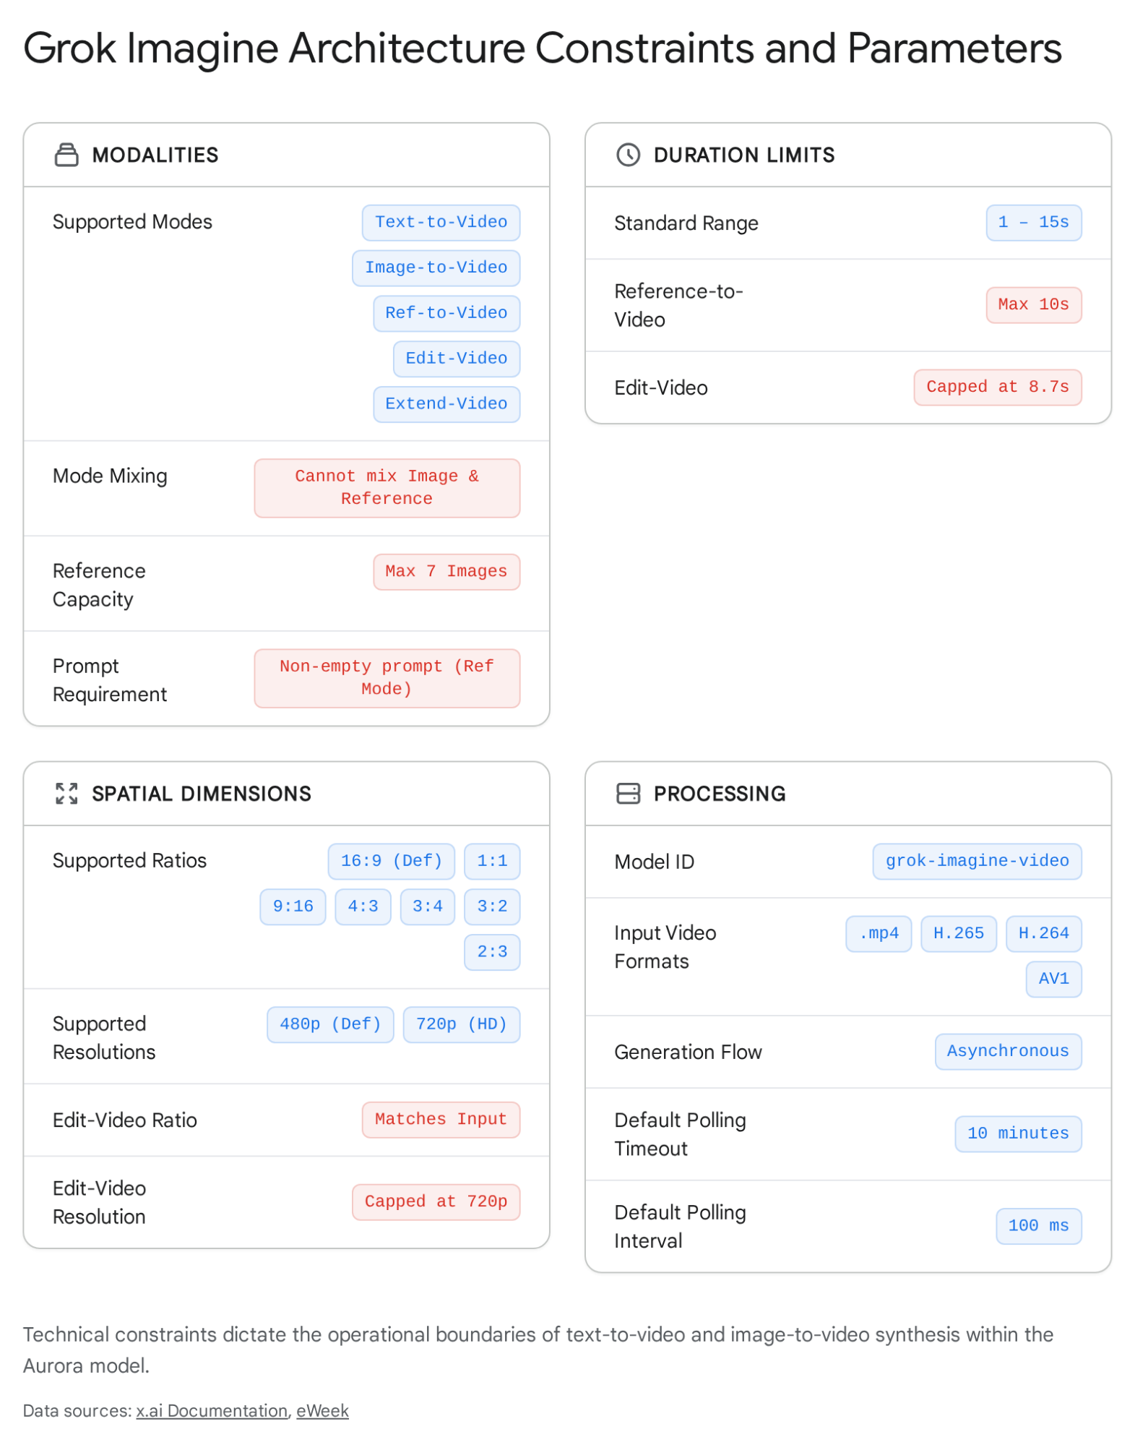

2. The Semantic Mechanics of AI Prompting: Moving Beyond Adjectives
A ubiquitous and costly failure in novice AI video generation is the over-reliance on qualitative adjectives—often termed within the industry as "quality spam." Prompts populated with subjective terms like "stunning," "breathtaking," "masterpiece," "epic," or "ultra-detailed" consume valuable token context windows while offering zero mechanical or geometrical instruction to the model's latent space.¹¹ The autoregressive nature of the Aurora model does not possess emotional context; it thrives on explicit, tangible visual descriptions.³
To achieve authentic Hollywood-grade cinematography, prompt engineers must adopt the exact vocabulary of a film director, a director of photography, a production designer, and a Foley artist. The semantic structure must prioritize tangible nouns, active verbs, exact temporal markers, and standardized technical terminology.³ For instance, prompting for an "early March morning" yields vastly superior physical results compared to the generic term "morning." The former explicitly instructs the model regarding the specific low angle of the sun, the likely presence of frost or atmospheric haze, and the precise diffuse quality of light filtering through the atmosphere.¹¹
Furthermore, the sequential processing of text prompts necessitates the strategic front-loading of critical information. Generative models, including Grok and contemporary systems like Veo 3, weight the earliest words in a prompt string significantly more heavily than trailing clauses.¹² A prompt structured systematically as + + is remarkably more stable than burying the primary subject at the conclusion of a convoluted descriptive paragraph.¹² Order dictates visual hierarchy.

2.1 The Fundamental "One Action" Rule
Temporal coherence in generative AI video remains a fragile construct. When a prompt commands multiple sequential or simultaneous actions (for example, "A man walking down the street while talking on the phone, then he drops his coffee and looks up at an airplane"), the model experiences severe semantic collision.¹² The system attempts to resolve all requested states concurrently, which manifests as morphological distortion. Body parts merge, objects spontaneously materialize or dissolve, limbs duplicate, and the temporal logic of the scene collapses into chaos.
The established industry standard for achieving photorealistic stability is the stringent adherence to the "One Action Per Prompt Rule".¹² A standard generated clip should focus entirely on a single, continuous physics-based motion: a subject slowly turning their head toward the lens, a vehicle drifting around a wet corner, or wind aggressively blowing across a wheat field. Complex narratives are built not by overloading single prompts with multifaceted actions, but by generating distinct, single-action clips and assembling them sequentially in non-linear editing (NLE) software.⁷

2.2 The Paradox of Negative Prompting
Unlike older image diffusion models that feature dedicated, explicit "negative prompt" input fields (where users can type concepts to be explicitly excluded from the render), natural language models like Grok struggle fundamentally with negation.¹¹ The architecture operates on attention mechanisms; therefore, mentioning an object, even with a negative prefix, forces the model's attention toward that concept's latent embedding, inadvertently increasing the statistical likelihood of its generation.¹³
For example, instructing the model to generate a character with "no earrings" or "unpierced ears" frequently results in the model hallucinating prominent, obtrusive jewelry as soon as the character's head turns to reveal their profile.¹³ Similarly, attempting to prevent the model from overlaying unwanted text by prompting "no subtitles, no captions, avoid text overlay" acts as a direct semantic trigger, virtually guaranteeing the appearance of textual artifacts and graphical overlays across the video.¹⁴
The empirical solution to this paradox is strict, exhaustive positive reinforcement.¹³ Instead of detailing what should be absent, the prompt must exhaustively describe what is present to crowd out unwanted elements. To avoid generating earrings, the prompt should detail "smooth, unadorned skin, clean jawline, bare ears".¹³ To avoid subtitles and text, the prompt must focus intensely and exclusively on the physical composition of the frame, the lighting, and the textures, actively avoiding any vocabulary remotely related to language, text, typography, writing, or reading.

3. The Foundational Guide: The 5-Layer Cinematic Prompt Architecture
Achieving consistent, studio-quality output across multiple generations requires a systematic, almost mathematical approach to prompt construction. The most effective methodology implemented by professional AI filmmakers and studio technicians is the 5-Layer Cinematic Architecture.⁹ By systematically compartmentalizing and controlling the Scene, Camera, Style/Lighting, Motion, and Audio, the creator establishes strict boundaries that minimize the AI's tendency to hallucinate unwanted or illogical elements.⁹
A standard structure follows a highly logical sequence, mirroring the pre-production planning of a physical film shoot. The prompt must begin by establishing the subject and environment, follow with the mechanical operation of the camera, dictate the lighting and artistic style, introduce the physics of motion, and conclude with the acoustic design.
Architecture Layer | Core Function | Semantic Focus | Example Terminology
Layer 1: Scene & Subject | Establishes the physical reality of the shot. | High-specificity nouns, exact ages, specific clothing textures, geographic markers. | "A woman in her early 30s wearing a textured blue linen jacket," "Minimalist concrete loft."
Layer 2: Camera Dynamics | Dictates the viewer's spatial relationship to the subject. | Focal lengths, shot sizes, mechanical movements, stabilization methods. | "85mm lens," "Over-the-shoulder shot," "Slow dolly-in," "Handheld shaky cam."
Layer 3: Lighting & Style | Controls atmospheric mood and color science. | Directional light, shadows, color palettes, physical rendering properties. | "Rembrandt lighting," "Golden hour," "High-contrast chiaroscuro," "Volumetric God rays."
Layer 4: Motion Physics | Defines the temporal evolution of the frame. | Environmental interactions, micro-expressions, specific kinetic impacts. | "Wind lifting stray hairs," "Shockwave ripples through grass," "Debris flying toward camera."
Layer 5: Audio & Foley | Directs native soundscape generation. | Acoustic properties, dialogue parameters, specific Foley sound effects, musical tones. | "Quiet engine hum," "Leather boots crunching on wet gravel," "Melancholic piano in E minor."

3.1 Establishing Scene and Subject Specificity
The foundation of the prompt must construct a highly specific reality. The generative model possesses vast knowledge but defaults to generic averages unless forcefully directed. Therefore, the physical condition of objects and subjects drastically alters the photorealistic output. Perfect surfaces appear synthetic; thus, introducing subtle imperfections forces the model to render higher-fidelity textures and complex geometry. Prompting for "a ceramic mug with a matte terracotta glaze and a small chip on the rim" produces a substantially more realistic render than the vague request for "a coffee mug".¹⁵
The subject must be grounded in an environment immediately. "A lone traveler on a cliff, foggy morning, epic scale" establishes immediate narrative context and forces the AI to calculate atmospheric depth.¹⁶

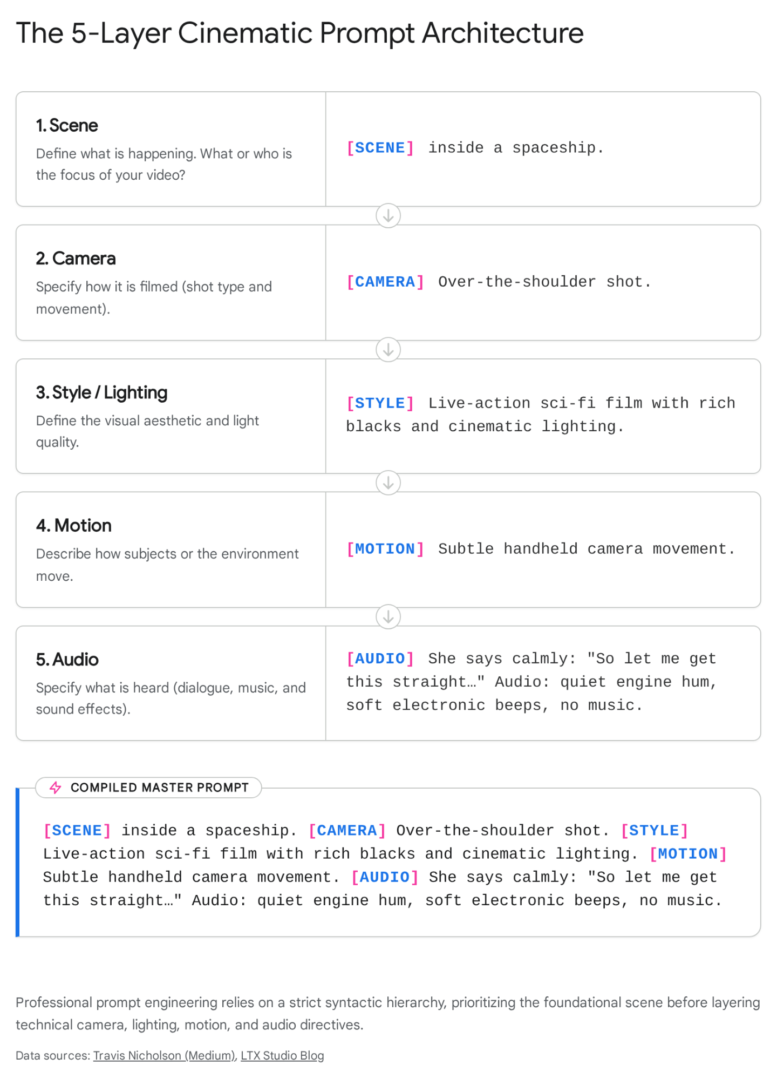

4. Cinematography Directives: Camera Operations and Lens Metadata
The second layer of the prompt architecture governs the spatial mechanics. Grok responds with high precision to professional cinematography nomenclature, allowing creators to dictate the exact optical characteristics of the simulated camera.⁹ Extracting metadata from real cinematic databases—such as ShotDeck—and injecting this real-world data (lens types, focal lengths, shutter speeds) into text prompts yields profound improvements in spatial realism.⁶

4.1 Lens Focal Lengths and Spatial Compression
To the AI latent space, a camera lens is a mathematical formula that dictates perspective and distortion. Mentioning specific millimeter markers drastically alters the field of view and spatial compression of the resulting video.
- Wide Angle (14mm - 24mm): Stretches the background, exaggerates perspective, and emphasizes the environment over the subject. Ideal for sweeping landscapes, establishing shots, and creating a sense of vast isolation.¹¹
- Standard / Human Eye (35mm - 50mm): Represents natural human perspective. Highly versatile, used for medium shots and documentary-style realism.¹⁶
- Telephoto / Portrait (85mm - 200mm): Compresses spatial depth, pulling the background closer to the subject while gracefully flattening facial features. Crucially, prompting an "85mm f/1.4 lens" instructs the model to generate a creamy, shallow depth of field (bokeh) that isolates the subject from a blurred background, a hallmark of high-budget portraiture.¹¹

4.2 Shot Sizing and Framing Nomenclature
The scale of the subject within the frame dictates the psychological impact of the scene.
- Extreme Close-Up (ECU) / Macro Focus: Isolates minute details, such as the iris of an eye, the texture of a fingernail, or condensation dripping down a glass.⁹ This forces the AI's rendering engine to prioritize high-resolution micro-textures, circumventing broad hallucinations.⁹
- Over-the-Shoulder (OTS): Establishes immediate spatial relationships between two subjects, adding depth and necessary narrative context, particularly for dialogue scenes.⁹
- High Angle / Low Angle: Alters the psychological perception of power. A low angle looking up imparts dominance and grand scale to the subject, while a high aerial view emphasizes vulnerability, surveillance, or vast geography.²⁰
- Dutch Angle: Tiling the camera horizon slightly off-axis to induce a sense of psychological unease, disorientation, or kinetic action.

4.3 Mechanical Camera Movement
If movement is not explicitly prompted, Grok may default to a static frame or, worse, a chaotic, drifting motion that feels artificial.⁹ Movement must be purposeful, singular, and described mechanically.

Camera Movement | Physical Execution | Cinematic Impact
Dolly In / Dolly Out | The camera is mounted on a track and physically pushed toward or pulled away from the subject.²² | Unlike a digital zoom, a dolly alters the parallax and 3D spatial depth of the environment, resulting in intense intimacy (in) or revealing context (out).¹⁹
Tracking / Trucking Shot | The camera moves laterally (left or right) alongside a moving subject, keeping pace with them.²¹ | Maintains focus on action sequences, allowing the background to blur dynamically, heightening the perception of speed.
Orbit / Arc | The camera moves in a smooth, continuous 360-degree curved path around a stationary subject.¹⁷ | Maps the 3-dimensional space of the character, creating a highly dynamic, heroic, or suspenseful revelation of the environment.¹⁷
Whip Pan | An extremely fast, aggressive horizontal rotation of the camera on its tripod axis.¹⁷ | Creates severe directional motion blur. Excellent for energetic transitions or revealing sudden threats in horror genres.¹⁷
Crash Zoom | A sudden, violent focal length shift making the subject appear instantly closer.¹⁷ | Mimics 1970s cinema or frantic documentary style; adds severe shock value or highlights a sudden realization.¹⁷
Handheld / Shaky Cam | Simulating a camera held by hand without digital stabilization.¹⁷ | Introduces micro-jitters and imperfect framing, lending a visceral, raw documentary or combat aesthetic to the footage.⁹
Crane Shot / Jib | Vertical movement through space, sweeping high to low or vice versa.²² | Establishes epic scale, moving from a micro detail to a macro environmental understanding rapidly.¹⁹

5. The Physics of Light: Cinematic Lighting Terminology
Lighting is the primary mechanism for establishing emotional resonance and volumetric form within a frame. Generative models are exceptionally adept at rendering complex lighting physics, but only if provided with explicit geometric and atmospheric terminology.²⁴ Merely asking for "good lighting" is insufficient; the prompt engineer must operate as a master gaffer.

5.1 Classical Studio and Portrait Lighting Systems
- Rembrandt Lighting: A cornerstone of classical portraiture and dramatic filmmaking. This technique involves placing a key light at a 45-degree angle to the subject, creating a distinct, illuminated triangle of light on the shadowed side of the cheek. Prompting for "Rembrandt lighting" provides deep characterization, dramatic form, and psychological complexity.²⁵
- Butterfly (Paramount) Lighting: Frontal, slightly elevated lighting that casts a soft, butterfly-shaped shadow directly beneath the subject's nose. Famously utilized to flatter facial features and emphasize cheekbones in golden-age Hollywood cinema, it yields a glamorous, highly controlled aesthetic.²⁵
- High-Key vs. Low-Key: High-key lighting involves flooding the scene with bright, even light to eliminate shadows, creating clean, airy, and sterile environments ideal for commercial advertising, comedies, or futuristic utopian scenes.²⁵ Conversely, low-key lighting relies on deep blacks, stark contrast, and isolated pools of light. It is essential for thrillers, film noir, and dramatic narratives.²⁶
- Negative Fill: A highly advanced professional technique. Rather than adding light, negative fill involves using black flags to absorb ambient bounced light, actively deepening the shadows on one side of a subject. Mentioning "negative fill" in a prompt forces the AI to increase contrast on faces, drastically enhancing three-dimensional volume and preventing flat generation.²⁵
- Rim Lighting / Halo Separation: Placing a strong backlight directly behind the subject to create a bright outline. This separates the subject from dark backgrounds, essential in low-key setups.²⁵

5.2 Environmental, Natural, and Practical Lighting
- Atmospheric Time of Day: "Golden hour" bathes scenes in warm, low-angle amber light with elongated shadows, perfect for romantic or nostalgic tones. "Blue hour" occurs just before sunrise or after sunset, providing a melancholic, soft cyan and deep purple wash without harsh directional shadows.²⁵
- Volumetric Lighting (God Rays): This instructs the rendering engine to calculate light interacting with particulate matter in the air. Prompting for "volumetric God rays filtering through a dusty window" forces the model to treat light shafts as physical, three-dimensional objects, instantly adding epic scale and atmosphere.²⁰
- Gobo Projections: Using stencils to cast patterned shadows. Prompting for a "Gobo projection of Venetian blinds" casts striking geometric lines across a detective's face or an interior wall, adding immense textural complexity to otherwise flat surfaces.²⁵
- Kelvin Color Temperature: Advanced prompt engineers manipulate exact Kelvin scales. Prompting for "mixed temperature lighting, 3200K warm practicals against 5600K cool moonlight" forces the AI to generate a highly cinematic bi-color aesthetic, mixing warm oranges with stark blues.²⁵

6. Materiality, Textures, and Rendering Engine Algorithms
To transcend the "uncanny valley" and eliminate the smooth, overly-perfect aesthetic characteristic of amateur AI generation, prompts must explicitly invoke industry-standard 3D rendering and materials science terminology. The Grok Imagine model has absorbed the lexicons of computer graphics (CG), allowing for extraordinary manipulation of light interaction upon matter.²⁰

6.1 Advanced Rendering Physics
- Global Illumination & Ray Tracing: Invoking terms like "global illumination," "path tracing," or "realistic light bounce" forces the model to calculate how light reflects off secondary surfaces. This process mathematically simulates colors bleeding from bright objects onto adjacent walls, deeply anchoring objects within their environments and preventing them from looking pasted into the frame.²⁰
- Ambient Occlusion: Instructs the rendering engine to deepen the shadows specifically in the crevices, corners, and intersecting geometry of objects. This creates localized contrast that prevents flat, unconvincing geometry.²⁰
- Caustics: Essential for water, glass, and refractive materials. Caustics define the intricate, web-like patterns of light that project through transparent mediums, elevating underwater or tabletop scenes to startling photorealism.²⁰
- Bloom & Halation: Simulates the optical artifact of a camera lens where intensely bright light (like a neon sign or a distant sun) bleeds over the edges of its source, creating a soft, luminous glow. Mentioning "red halation" mimics the specific chemical reaction of classic cinematic film stocks.²⁰

6.2 Material Substrates and Film Stocks
- Subsurface Scattering (SSS): This is arguably the most critical technical directive for rendering organic matter. SSS simulates the behavior of light penetrating a translucent surface, scattering beneath it, and exiting at a different point.²⁰ Without SSS, human skin appears like opaque plastic or clay. Invoking "subsurface scattering" ensures skin, wax, leaves, and marble exhibit a lifelike, dewy, and fleshy luminescence.²⁰
- Physically Based Rendering (PBR): A CG workflow standard that defines materials based on their real-world micro-surface properties (roughness, metallicity, albedo). Adding "PBR textures" to a prompt ensures that a rusty pipe, a silk dress, and a wet asphalt road react uniquely and accurately to the same light source.²⁰
- Specific Film Stocks: Referencing physical, analog film chemistry acts as a stylistic shortcut for the AI. Mentioning "Kodak Ektar 100" generates vibrant, muted earth tones. "CineStill 800T" produces a cool tungsten balance with its signature red glowing highlights, heavily favored for cyberpunk or modern night photography.¹¹ "35mm film grain" adds the requisite analog noise that fools the eye into perceiving reality.²⁶
- Render Engine Aesthetics: Referencing specific software engines forces the AI into a particular commercial aesthetic. "Octane Render" or "V-Ray" typically yields hyper-polished, commercial-grade 3D art, while an "Unreal Engine 5 aesthetic" pushes the generation toward high-fidelity, real-time cinematic gaming visuals.²⁰

7. Audiovisual Synchronization and Foley Sound Design
Perhaps the most disruptive capability of the Grok Imagine/Aurora architecture is its capacity for native, synchronized audiovisual generation.³ Traditional generative pipelines require exporting silent AI video to separate, dedicated audio synthesis platforms. Grok, however, processes audio tokens in parallel with visual tokens, allowing for embedded dialogue, orchestral music, and intricate Foley sound design generated natively within the same inference pass.³

7.1 Orchestrating Foley and Environmental Acoustics
If audio is left unspecified in the prompt, the model frequently defaults to generic, royalty-free-style background music that detaches the viewer from the scene.⁹ Precise auditory prompting is mandatory for cinematic immersion. Advanced sound generation models (similar to the underlying logic of MultiFoley or WaveSpeedAI) utilize Root Mean Square (RMS) envelope tracking to align sound semantics with visual impacts.³²
Creators must describe the exact acoustic properties of the environment. Prompts must include terms detailing the source, texture, and distance of the sound.³⁴ Instead of prompting "car noises," the prompt must specify "a low-frequency, quiet V8 engine hum with distant metropolitan sirens".⁹ To ground character movement, specify "heavy leather boots crunching on wet gravel" or "metallic sword impacts sparking against steel".⁹
Musical scoring requires defining the genre, instrumentation, and emotional tone. Directives such as "a slow, melancholic piano melody in E minor," "a booming Hans Zimmer-style brass braaam," or "synth-heavy cyberpunk arpeggios" yield highly specific audio beds.⁹ Furthermore, audio segregation is a vital technique; explicitly stating "Audio: ambient wind only, NO music" helps isolate sound effects, providing a clean audio stem for post-production mixing in external software.⁹

7.2 Navigating Dialogue and Lip-Sync Constraints
While Grok handles single-character dialogue effectively, achieving accurate lip-sync and character continuity, it struggles fundamentally with complex, multi-character interactions within a single generation clip.¹⁴ If prompted for a back-and-forth conversation, the model frequently conflates the dialogue tokens, causing characters to speak simultaneously or mapping the incorrect voice profile to the wrong visual character.¹⁴
To circumvent this architectural limitation, engineers must isolate character dialogue into distinct, single-shot generations and meticulously define the voice parameters to maintain consistency across subsequent cuts. A highly effective technique is to embed acoustic engineering specifications directly into the dialogue prompt.
Rather than simply stating "She says," the prompt should define the exact vocal apparatus: "Voice specification: Nigerian female, late-20s, 65 dB volume, 140 words per minute pace, 220 Hz pitch range, crisp articulation, dry acoustic resonance. She says calmly: ''".³⁵ This hyper-specificity prevents the model from randomly shifting voice profiles between generated clips, allowing editors to stitch a coherent conversation together in post-production.

8. Genre-Specific Prompt Engineering Protocols
The application of the 5-Layer Cinematic Architecture requires severe tonal shifts depending on the cinematic genre being produced. Each genre demands a distinct vocabulary of lenses, lighting setups, textures, and Foley acoustics. Utilizing generic terms like "make it look like a scary movie" results in algorithmic confusion; the AI requires exact modifiers.

8.1 Cinematic Horror and Psychological Thriller
The horror genre relies heavily on visual obscurity, implied threats, and aggressive, deeply unsettling auditory cues.³⁷ The visual frame must actively conceal information to build psychological tension, while the soundscape does the heavy lifting of inducing dread.
- Lighting: Must be low-key, high-contrast, with deep, impenetrable shadows. Utilize "Silhouette style," "Under lighting" (which projects unnatural shadows upward, mimicking a flashlight under a chin to distort facial geometry), and cold "Lunar glow".²⁵
- Camera Operations: Utilize "Dutch angles" to induce vertigo, a "slow, creeping dolly-in" to build unbearable anticipation, or "static voyeuristic wide shots" through a "peeping-hole / fisheye lens" to simulate a stalker's perspective.¹⁹
- Textures: Degrade the image with "high ISO film grain," "grimy, wet surfaces," and "desaturated, sickly green color palettes".²⁹
- Audio Design (SFX): The Foley must be oppressive and atonal. Prompt explicitly for "low-frequency organic drones," "heavy metallic squeaks," "sudden blasting impacts," "atonal string rises," "wet whispers," and rhythmic "heartbeat drum pulses".³⁷

8.2 The American Western
The Western genre is defined by vast, hostile landscapes and rugged individualism, requiring expansive optical fields, harsh light, and intense textural grit.⁴² It is a genre built on the mythology of dirt and sun.
- Lighting: Relies heavily on natural atmospheric phenomena. Use "Golden hour," "sun-drenched, harsh top-lighting," "long harsh shadows stretching across the ground," "backlit silhouettes," and "dusty atmospheric diffusion".²⁶
- Camera Operations: "Extreme wide establishing shots" to emphasize isolation, "low-angle heroic framing" to aggrandize the gunslinger, and "slow panning across vast plains".²¹
- Textures: Sweat-stained fabrics, cracked leather, rusted metal, swirling dust particles, authentic "35mm film stock," and a warm, baked "sepia or terracotta grading".¹⁶
- Audio Design: Focus on the isolation of the environment. "Wind howling through arid canyons," "leather creaking under tension," "dry footsteps crunching on dirt," "horse snorts," and a "distant, lonely acoustic guitar sting."

8.3 Film Noir and Detective Fiction
Rooted deeply in 1940s cinema, Film Noir requires strict, mathematical control over monochromatic contrast and urban atmospheric elements to convey moral ambiguity.⁴⁵
- Lighting: The core of Noir is "Chiaroscuro" and "high-contrast monochrome." Utilize "Gobo projection of window blinds" to slice characters with light, "stark highlights against pitch-black shadows," and "neon reflections bleeding on wet pavement".²⁵
- Camera Operations: "Medium tracking shots" following subjects through alleys, "low angle" to emphasize looming threats, and a "static tripod" for interrogations.
- Textures: Rain-slicked cobblestone streets, thick cigarette smoke lingering in the air, heavy wet wool trench coats, and pure monochromatic grayscale without color bleed.⁴⁵
- Audio Design: "Steady heavy rain hitting pavement," "a distant, melancholic jazz saxophone," and "slow, deliberate footsteps echoing in an empty alleyway."

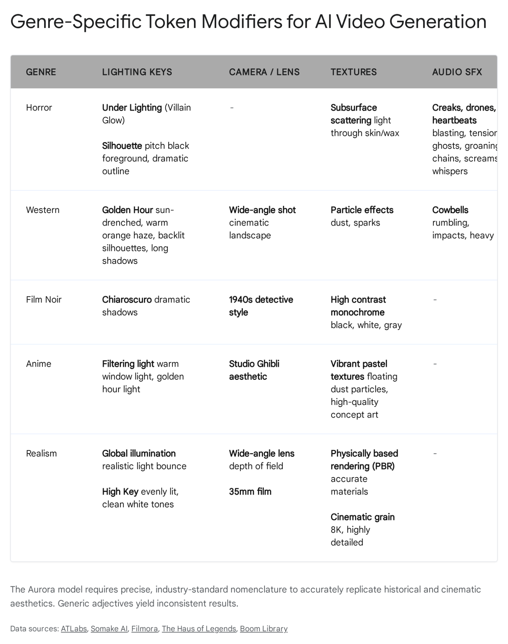

8.4 Anime and Studio Ghibli Concept Art
Generative AI models excel remarkably at 2D and 2.5D animation styles, provided the correct rendering instructions are applied to flatten the 3D physics and boost the color vibrance.²⁹
- Lighting: "Soft, ethereal lighting," "glowing window light," and "flat shading" to eliminate hyper-realistic 3D volume.
- Camera Operations: "Static scenic composition" to emulate painted backgrounds, and a "slow 2D pan left" to mimic traditional animation multiplane camera techniques.
- Textures: "Vibrant pastel textures," "watercolor backgrounds," "cel-shaded characters with thick line art," "floating glowing dust particles," and "lush, overgrown stylized foliage".²⁹
- Audio Design: "Wind rustling softly through leaves," "whimsical wind chimes," and "soft, sweeping orchestral strings."

8.5 Documentary and Realism (Cinéma Vérité)
To simulate nonfiction reality and bypass the overly polished look of commercial film, the prompt must intentionally introduce mechanical imperfections, spontaneous, unchoreographed movement, and unpolished lighting.²¹
- Lighting: "Overcast natural light," "mixed color temperature lighting," "harsh fluorescent overheads," and "flat, unstyled lighting".²⁵
- Camera Operations: "Handheld, shaky camera," "rapid auto-focus hunting," "snap zoom adjustments mid-shot," and a raw "documentary style".¹⁷
- Textures: "Digital noise artifacts," "amateur video look," and explicitly commanding "no color grading."
- Audio Design: "Unfiltered ambient room tone," "muffled background chatter," and the specific sound of "wind hitting the camera microphone."

9. The Ultimate Grok Prompt Construction Guide and Templates
Synthesizing the technical capabilities, semantic mechanics, physical rendering laws, and genre modifiers leads directly to a reproducible, industrial templating system. Professional operators do not improvise prompts; they utilize structured formulas.

9.1 The "Trailer Beat" Assembly Framework
Operating AI video generation tools demands a psychological shift from traditional filmmaking. The operational mantra for AI cinematography is: "Volume beats perfection".¹² Attempting to craft a single, flawless, omnipotent prompt is a statistical failure due to the inherent randomness in the model's latent space.¹²
To generate a cohesive short film, the creator must execute multiple distinct prompts, rendering them as separate clips to be stitched together later in editing software. The "Trailer Beat" method structures prompts to capture specific, modular story beats, ensuring the AI is only tasked with one complex variable at a time.¹⁶

Narrative Sequence | Focus of the Generation Prompt | Typical Technical Directives
Beat 1: Establishing Shot | Focuses entirely on geography, scale, and environmental lighting. No complex character actions are permitted here. | 24mm wide angle, slow dolly-in, volumetric lighting, drone acoustics.¹⁶
Beat 2: Character Intro | Medium shot or Close-up. Focuses heavily on character texture, subsurface scattering of skin, and subtle ambient micro-motion. | 85mm lens, Rembrandt lighting, shallow depth of field, subtle breathing motion.¹⁶
Beat 3: Action / Conflict | Prioritizes kinetic physics and aggressive Foley sound design. Character detail can be sacrificed for motion clarity. | Fast shutter speed, whip pan, motion blur, heavy impact SFX.¹⁶
Beat 4: The Reaction | Slow movement, dramatic lighting shift, intense emotional resonance on a static face. | Extreme close-up, negative fill, high contrast, melancholic score.¹⁶
A prevalent technique for achieving an authentic Hollywood look during this assembly process involves aspect ratio manipulation, known as the 21:9 Cinematic Crop Hack. While Grok natively supports 16:9, true anamorphic cinema utilizes a wider 2.35:1 or 21:9 ratio.⁶ Creators generate the video at standard 16:9, deliberately prompting for "wide framing, extra headroom," and then apply black cinematic letterboxing in post-production to achieve the 21:9 look. This physically crops out AI artifacts that frequently occur at the absolute top and bottom edges of the generated frame.⁶

9.2 The Universal Grok Video Prompt Templates
For daily production operations, engineers should utilize the following fill-in-the-blank bracketed templates. These templates ensure all five layers of the Cinematic Architecture are addressed sequentially, preventing the model from hallucinating missing data.
The Master Structural Syntax:
+ of... +..
Template 1: The Cinematic Portrait (Ideal for Image-to-Video) This template is optimized for generating high-emotion, realistic character shots, often utilizing a Midjourney reference image as the base.⁴
- Prompt: Slow dolly-in, 85mm extreme close-up of.. The background is a [Location], completely out of focus with deep bokeh. Golden hour directional lighting, subsurface scattering on skin, natural 35mm film grain, Kodachrome aesthetic. Audio: [Ambient environmental sound], no music.
Template 2: The Epic Establishing Landscape (Ideal for Text-to-Video)
This template is optimized for world-building, conveying grand scale, and executing architectural reveals where environmental physics are paramount.
- Prompt: Slow sweeping drone shot, 24mm extreme wide angle lens over [Vast Location/Geography]. [Macro-environmental motion, e.g., Heavy storm clouds rolling quickly, ocean waves crashing, thousands of birds taking flight]. High-key lighting, volumetric God rays breaking through the atmospheric haze. Global illumination, epic cinematic scale, high dynamic range (HDR), highly detailed PBR textures. Audio:, majestic brass orchestral swell.
Template 3: The High-Energy Action Shot This template sacrifices fine aesthetic detail to prioritize combat, sports, mechanical movement, and sheer kinetic chaos without temporal melting.⁹
- Prompt: Handheld shaky camera, aggressive whip pan tracking as they [Aggressive Action/Movement] through [Location]. Severe motion blur, debris flying toward the camera lens, high shutter speed. High-contrast harsh lighting, dirt and grime textures, hyper-realistic, Unreal Engine 5 rendering aesthetic. Audio:, heavy breathing, frantic electronic synthesizer bass.
Template 4: The Noir / Suspense Dialogue Setup This template is optimized for dialogue generation, locking in specific acoustic profiles to prevent voice hallucination.³⁵
- Prompt: Static tripod, over-the-shoulder medium shot of looking at in a [Location]. slowly turns their head. Classic 1940s Film Noir, high-contrast black and white, chiaroscuro lighting, Gobo shadows across the face. Voice specification:. says calmly: "". Audio: Steady rain hitting pavement, distant police siren, NO music.
The transition from rudimentary text-to-image to fully realized text-to-video audiovisual generation via models like Grok's Aurora demands a rigorous, highly technical approach to prompt engineering. Success is no longer dictated by the creative use of adjectives, but by the precise, systematic deployment of optical physics, rendering terminology, and acoustic engineering specifications. By adhering to the strict "One Action" rule, applying the 5-Layer Cinematic Prompt Architecture, and leveraging the exact vocabulary of Hollywood directors and 3D rendering artists, creators can consistently bypass the uncanny valley and produce profound cinematic art.

Works cited
- News: Research, Product & Company Updates | xAI, accessed April 28, 2026, https://x.ai/news
- Grok Imagine API - xAI, accessed April 28, 2026, https://x.ai/news/grok-imagine-api
- Grok Imagine Video | Image to Video API - Replicate, accessed April 28, 2026, https://replicate.com/xai/grok-imagine-video
- Grok xAI Video Generation Capabilities 2026: Features and Latest Status - GenAIntel, accessed April 28, 2026, https://www.genaintel.com/guides/grok-xai-video-generation-capabilities-2026
- Video Generation | xAI Docs, accessed April 28, 2026, https://docs.x.ai/developers/model-capabilities/video/generation
- The SECRET to Stunning AI Video Prompts! - YouTube, accessed April 28, 2026, https://www.youtube.com/watch?v=vRNHNNliDVM
- How to Create Long-Form Videos with Free Grok AI (2026 Tutorial) - YouTube, accessed April 28, 2026, https://www.youtube.com/watch?v=yTp0tkc2EVg&vl=en-US
- Grok — Truth-seeking AI Chatbot with Voice & Image Generation - xAI, accessed April 28, 2026, https://x.ai/grok
- The Complete Guide to Prompting Grok for AI Videos | by Travis Nicholson - Medium, accessed April 28, 2026, https://travisnicholson.medium.com/the-complete-guide-to-prompting-grok-for-ai-videos-917ed6af1758
- xAI Launches Grok Imagine 1.0 Video Generator Amid Ongoing Safety Controversies, accessed April 28, 2026, https://www.eweek.com/news/grok-imagine-1-0-ai-video-generator/
- Grok Imagine Prompts: Copy-Ready Examples and Tips - Picsart, accessed April 28, 2026, https://picsart.com/blog/grok-imagine-prompts/
- everything I learned after 10000 AI video generations (the complete guide) - Reddit, accessed April 28, 2026, https://www.reddit.com/r/PromptEngineering/comments/1mvfcrr/everything_i_learned_after_10000_ai_video/
- How can I prompt for something I DON'T want in a video : r/grok - Reddit, accessed April 28, 2026, https://www.reddit.com/r/grok/comments/1qh1glp/how_can_i_prompt_for_something_i_dont_want_in_a/
- Best practice to better control dialogues in I2V-Videos done with Grok Imagine - Reddit, accessed April 28, 2026, https://www.reddit.com/r/grok/comments/1qs2d20/best_practice_to_better_control_dialogues_in/
- GPT Image 2 Prompt Guide + 70 Prompts, accessed April 28, 2026, https://www.imagine.art/blogs/gpt-image-2-prompt-guide
- Cinematic prompt templates I actually reuse (image + video) — plus a quick “why it fails” checklist - Reddit, accessed April 28, 2026, https://www.reddit.com/r/PromptEngineering/comments/1qf3ge1/cinematic_prompt_templates_i_actually_reuse_image/
- Camera Terms, Prompts, & Examples - Runway, accessed April 28, 2026, https://help.runwayml.com/hc/en-us/articles/47313504791059-Camera-Terms-Prompts-Examples
- The Complete AI Video Prompt Ultimate Guide 2025: My Journey from Confused Creator to Confident Prompter - DomoAI, accessed April 28, 2026, https://domoai.app/blog/a-video-prompt-2025
- ALL Camera Movement Prompts in AI Filmmaking (38 Cinematic Moves) - YouTube, accessed April 28, 2026, https://www.youtube.com/watch?v=zQI_pWw9qWo
- AI GENERATIVE ART PROMPT REFERENCE SHEET - The Haus Of Legends, accessed April 28, 2026, https://thehausoflegends.com/ai-generative-art-prompt-reference-sheet/
- The complete guide to creative AI video prompts - Envato, accessed April 28, 2026, https://elements.envato.com/learn/ai-video-prompts
- 50 AI Camera Movement Prompts for Cinematic AI Video - ImagineArt, accessed April 28, 2026, https://www.imagine.art/blogs/ai-camera-movement-prompts
- Veo 3 Video Prompt Examples and Best Practices | Powtoon Blog, accessed April 28, 2026, https://www.powtoon.com/blog/veo-3-video-prompt-examples/
- AI Video Prompt Guide: How To Write AI Video Prompts | LTX Studio, accessed April 28, 2026, https://ltx.studio/blog/ai-video-prompt-guide
- AI Filmmaking: The Ultimate Guide to Cinematic Lighting (20 Prompts) - YouTube, accessed April 28, 2026, https://www.youtube.com/watch?v=RCHw0PtE92M
- 27 Cinematic Lighting Looks for AI Prompts | Complete Visual Guide, accessed April 28, 2026, https://www.atlabs.ai/blog/27-cinematic-lighting-looks-ai-prompts-guide
- Artificial Intelligence (AI) Terms Glossary | BigMotion AI, accessed April 28, 2026, https://www.bigmotion.ai/ai-terms-glossary
- Ultimate AI glossary with key terms and definitions - Artlist Blog, accessed April 28, 2026, https://artlist.io/blog/ai-glossary/
- Best Grok AI Image & Video Prompts 2026: Examples & Pro Tips - Filmora, accessed April 28, 2026, https://filmora.wondershare.com/ai-prompt/grok-prompts.html
- What is subsurface scattering? - Adobe Substance 3D, accessed April 28, 2026, https://www.adobe.com/products/substance3d/discover/subsurface-scattering.html
- Audio for Video & Foley - WaveSpeed AI, accessed April 28, 2026, https://wavespeed.ai/collections/audio-for-video
- Video-Foley: Two-Stage Video-To-Sound Generation via Temporal Event Condition For Foley Sound - arXiv, accessed April 28, 2026, https://arxiv.org/html/2408.11915v2
- MultiFoley: Video-Guided Foley Sound Generation with Multimodal Controls | AI Art Weekly, accessed April 28, 2026, https://aiartweekly.com/tools/video-guided-foley-sound-generation-with-multimodal-controls
- Generate Sound Effects Using AI - Adobe - YouTube, accessed April 28, 2026, https://www.youtube.com/watch?v=fyxyDY3Y3Oo
- Make multiple characters speak on Grok (A Trick that works) - YouTube, accessed April 28, 2026, https://www.youtube.com/watch?v=jJpYL1A6iI0
- trying to direct a scene with multiple subjects engaging in dialog is absolutely useless with grok imagine - Reddit, accessed April 28, 2026, https://www.reddit.com/r/grok/comments/1ovmoe5/trying_to_direct_a_scene_with_multiple_subjects/
- Horror Sound Effects | Cinematic Horror - BOOM Library, accessed April 28, 2026, https://www.boomlibrary.com/sound-effects/cinematic-horror/
- 20+ High Quality Cinematic Horror Sound Effects - YouTube, accessed April 28, 2026, https://www.youtube.com/watch?v=y_DYtykc7TY
- Prompt Guide to Cinematic AI Videos with Higgsfield Popcorn & Recast, accessed April 28, 2026, https://higgsfield.ai/blog/Prompt-Guide-to-Cinematic-AI-Videos
- Cinematic Horror Sounds & FX | SFX, Pads, Soundscapes & More! - YouTube, accessed April 28, 2026, https://www.youtube.com/watch?v=ZNznVtRssb8
- Download Free Cinematic Sound Effects | Mixkit, accessed April 28, 2026, https://mixkit.co/free-sound-effects/cinematic/
- Western (genre) - Wikipedia, accessed April 28, 2026, https://en.wikipedia.org/wiki/Western_(genre)
- Breaking down a Genre: Westerns - The_FilmPost, accessed April 28, 2026, https://thefilmpost.medium.com/breaking-down-a-genre-westerns-ac140eb8d7e8
- The Indie Filmmaker's Guide to The Western - PremiumBeat, accessed April 28, 2026, https://www.premiumbeat.com/blog/the-indie-filmmakers-guide-to-the-western/
- AI Noir Film Generator: Create High-contrast Art - NightCafe, accessed April 28, 2026, https://creator.nightcafe.studio/tools/high-contrast-noir-film-generator
- Create Film Noir Hollywood Videos with AI | Hypernatural, accessed April 28, 2026, https://hypernatural.ai/video-styles/film-noir-hollywood

